Title: **Basic Motor Controls and Single-Phase Motors** Worksheet: 3

Course: Intro to Automation Unit: Manual Motor Control CLO: 1

Name ______________________________ Grade ________ Date ________________

**Objectives**

1. Student shall identify the basic components of an AC induction motor.
2. Student shall list items found on a single-phase motor nameplate.
3. Student shall calculate the acceptable input voltage range given the motors rated voltage.

**Assessment**

Students shall demonstrate a comprehension of the objectives listed above by scoring a minimum of 75% on this Worksheet. Grading shall be based on the answer key.

**Instructions**

Identify each component of an AC single-phase induction motor.

1. 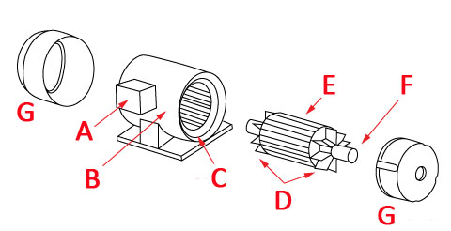Fans _____
2. Rotor _____
3. Terminal Box _____
4. End Bell _____
5. Stator _____
6. Shaft _____
7. Motor Frame _____

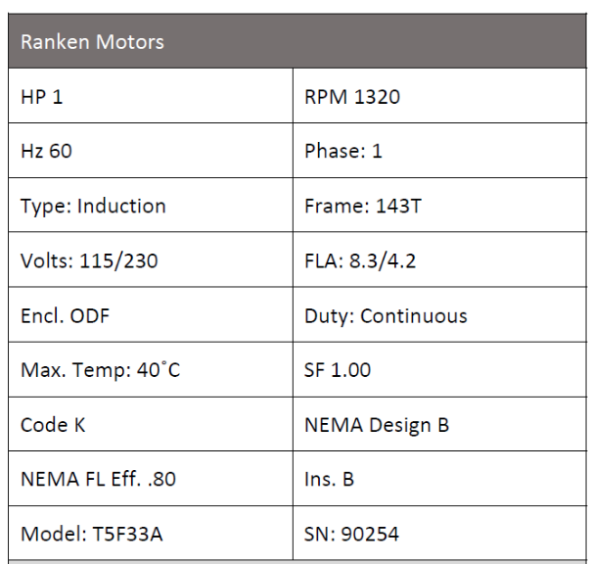**Instructions**

Answer each of the individual questions below.

1. What is the RPM for this motor? ____________
2. What nominal voltage level would you use to connect to this motor? ___________
3. What is the acceptable range of voltage input to this motor? _______ to _______
4. What is the horsepower for this motor? __________
5. How many watts should this motor dissipate? _____
6. Select the two properties that will dictate the rotational speed of an AC motor.
7. Source voltage
8. Motor horsepower
9. Number of poles
10. Input frequency

This page left intentionally almost blank